

50.005 Computer System Engineering

**NS Lab 1: Internet Routes and Measurement of Round Trip Times**

# Name: ID:

Kwa Li Ying

1003833

**Overview**

In this lab exercise, you will learn how to use ping and traceroute to measure round trip times and find network routes.

# Learning objectives

At the end of this lab exercise, you should be able to:

* Understand how the ping and traceroute utilities work.
* Use the ping utility to measure network round trip times.
* Use the traceroute utility to find network routes.
* Observe and understand the effects of varying packet sizes on delays experienced.

# Preparation

You will need ping and traceroute to be installed on your Ubuntu virtual machine. Most Ub- untu installations should already include ping by default. You can install traceroute by run- ning “sudo apt-get install traceroute” from the command line.

# Part 1: Measurement of round trip times using ping

The ping utility is one of the most widely-used network utilities. It enables you to measure the time that it takes for a packet to travel through the Internet to a remote host and back.

The ping utility works by sending a short message, known as an *echo-request*, to a remote host using the Internet Control Message Protocol (ICMP). When a host that supports ICMP receives an echo-request message, it replies by sending an echo-response message back to the originating host.

In the first part of this lab exercise, you will use the ping utility to send echo requests to a num- ber of different hosts. In many of the exercises, you will be referring to hosts using their DNS names rather than their IP addresses. For more information about ping, you can look up its man- ual page by running “man ping” from the command line.

# Round trip times

Use ping to send 10 packets to each of the following hosts. Each packet should have a size of 56 bytes, and there should be an interval of 5 seconds between each packet sent.

[www.csail.mit.edu](http://www.csail.mit.edu/) [www.berkeley.edu](http://www.berkeley.edu/) [www.usyd.edu.au](http://www.usyd.edu.au/) [www.kyoto-u.ac.jp](http://www.kyoto-u.ac.jp/)

*Note:* The size of each packet is 56 bytes by default, but you may observe that the actual size of the packet is larger than 56 bytes. You can look up the manual for ping to understand why such a discrepancy exists.

**Question 1 (10pt):** For each host, record the percentage of packets sent that resulted in a suc- cessful response. Record also the minimum, average, and maximum round trip times for the packets that resulted in a response.

|  |  |  |  |  |
| --- | --- | --- | --- | --- |
| **Website** | **Successful Percentage**  **%** | **Min RTT** | **Average RTT** | **Max RTT** |
| [www.csail.mit.edu](http://www.csail.mit.edu/) | 100 | 5.196 | 12.707 | 70.237 |
| [www.berkeley.edu](http://www.berkeley.edu/) | 100 | 210.583 | 333.268 | 609.873 |
| [www.usyd.edu.au](http://www.usyd.edu.au/) | 100 | 97.984 | 99.109 | 101.816 |
| [www.kyoto-u.ac.jp](http://www.kyoto-u.ac.jp/) | 100 | 77.445 | 80.892 | 90.901 |

**Question 2 (10pt):** Describe and explain the differences in the minimum round trip time to each of these hosts.

The round trip time depends on the respective nodal delays, which is affected by 4 factors: processing delay, queueing delay, transmission delay and propagation delay. Since the routing to and from each of the different destinations are different, this will result in different routers and links traversed, which will lead to different distances and different number of hops. As a result, the propagation delay is most likely the biggest factor that accounts for the differences in the (minimum) round trip time.

Additionally, MIT could be a content provider network that only carries traffic to and from its own servers, thus accounting for the much shorter (minimum) round trip times as compared to the rest.

**Question 3 (10pt):** Repeat the exercise using packet sizes of 56, 512 and 1024 bytes. Record the minimum, average, and maximum round trip times for each of the packet sizes. Why are the minimum round-trip times to the same hosts different when using 56, 512, and 1024–byte pack- ets?

|  |  |  |  |  |  |
| --- | --- | --- | --- | --- | --- |
| **Website** | **Data byte packets** | **Successful Percentage %** | **Min RTT** | **Average RTT** | **Max RTT** |
| [www.csail.mit.edu](http://www.csail.mit.edu/) | **56** | 100 | 5.553 | 12.763 | 44.420 |
|  | **512** | 100 | 4.692 | 6.649 | 11.228 |
| **1024** | 100 | 4.890 | 7.190 | 11.851 |
| [www.berkeley.edu](http://www.berkeley.edu/) | **56** | 90 | 212.676 | 332.299 | 549.066 |
|  | **512** | 80 | 212.475 | 299.195 | 524.735 |
| **1024** | 90 | 211.480 | 281.865 | 556.941 |
| [www.usyd.edu.au](http://www.usyd.edu.au/) | **56** | 100 | 98.580 | 110.604 | 188.833 |
|  | **512** | 100 | 98.828 | 101.267 | 106.630 |
| **1024** | 100 | 98.427 | 98.950 | 99.604 |
| [www.kyoto-u.ac.jp](http://www.kyoto-u.ac.jp/) | **56** | 100 | 77.660 | 78.465 | 80.682 |
|  | **512** | 100 | 77.948 | 79.109 | 79.984 |
| **1024** | 100 | 78.328 | 81.654 | 98.977 |

When the packet size is different, this will affect the transmission delay aspect of the total nodal delay. Generally, the greater the packet length/size, the higher the transmission delay, and hence the RTT should be greater. However, the increase in transmission delay should be small as compared to the fluctuation in propagation delay. Therefore, the effect of packet size on RTT is not very significant (and obvious) in the table values.

# Unanswered pings

Use ping to send 100 packets to the following host. Each packet should have a size of 56 bytes, and there should be an interval of 5 seconds between each packet sent.

[www.wits.ac.za](http://www.wits.ac.za/)

**Question 4 (10pt):** Record the percentage of the packets sent that resulted in a successful re- sponse. What are some possible reasons why you may not have received a response? (Be sure to check the host in a web browser.)

Percentage of packets set: 0%. The web server may have set up a firewall to block anything other than the port traffic for the services offered (including ICMP packets). It could be possible that the server does not exist, or that the computer could not establish a connection to the host server as well. However, keying the URL into a web browser allows the page to load, meaning that the host is alive and connection can be established. Therefore, the first reason (firewall) is more likely to be true.

# Part 2: Understanding Internet routes using traceroute

The traceroute utility is another useful network utility. It enables you to trace the route taken by a packet from your machine to a remote host.

Here is an example of the output produced when traceroute is used to trace the route taken by a packet to [www.mit.edu.](http://www.mit.edu/)

[traceroute to www.mit.edu](http://www.mit.edu/) (118.215.81.86), 30 hops max, 60 byte pack- ets

1 192.168.9.2 (192.168.9.2) 0.221 ms 0.193 ms 0.107 ms

2 10.12.0.1 (10.12.0.1) 3.363 ms 2.555 ms 3.253 ms

3 172.16.1.106 (172.16.1.106) 3.072 ms 3.416 ms 3.418 ms

4 172.16.1.210 (172.16.1.210) 4.977 ms 4.712 ms 4.921 ms

5 192.168.22.27 (192.168.22.27) 4.806 ms 6.521 ms 6.451 ms

6 103.24.77.1 (103.24.77.1) 7.172 ms 3.590 ms 3.187 ms

7 201.210-193-8.qala.com.sg (210.193.8.201) 4.312 ms 9.056 ms

7.870 ms

8 137.203-211-158.unknown.qala.com.sg (203.211.158.137) 8.904 ms

6.690 ms 6.555 ms

9 213.203-211-158.unknown.qala.com.sg (203.211.158.213) 7.710 ms

5.423 ms 5.193 ms

10 203.116.10.125 (203.116.10.125) 6.783 ms 6.705 ms 6.440 ms

Each line in the output begins with a host on the route from your computer to [www.mit.edu,](http://www.mit.edu/) followed by the round-trip times for 3 packets sent to that host. For more information about traceroute, you can look up its manual page by running “man traceroute” from the com- mand line.

# Basics

**Question 5 (10pt):** Explain how traceroute discovers a path to a remote host. (*Hint:* The

traceroute manual will be helpful for answering this question.)

Traceroute tracks the route packets taken from an IP network on their way to the remote host. It utilizes the IP protocol’s time to live (TTL) field and attempts to elicit an ICMP TIME_EXCEEDED response from each gateway along the path to the host.

The traceroute program starts by sending 3 packets (probes) that will reach router i (reached after i hops) on the path towards the destination, and router i will return the packets to the sender. The number i starts from 1 and is increased by 1 each time the packets are returned, and i is bound by an upper limit (e.g. 64 hops max).The round trip time (to router i and back) is then measured and reflected for each packet. This continues until the destination is reached or the maximum number of hops is reached.

# Route asymmetries

In this exercise, you will run traceroute in two opposite directions. First, you will run tra- ceroute on a remote host to see the route taken to your network. You will also run trace- route from your computer to see the route taken to that host.

**Step 1:** Find out your computer’s public IP address. (*Hint:* You can use a website like <http://www.whatismypublicip.com/>, or search for “*what is my ip*” using Google’s search engine.)



**Step 2:** Visit <https://www.uptrends.com/tools/traceroute> in your web browser. Enter your com- puter’s public IP address, select the “from Location” and click “Start Test” to start a trace- route to your computer. Follow the steps shown below for at least three locations namely: New York, Amsterdam, Tokyo.

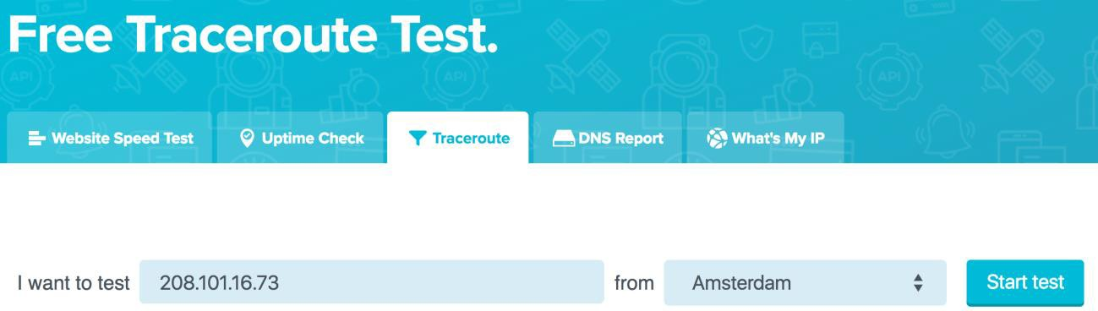

**Step 3:** After traceroute finishes running, you should be able to view the route taken from specified location to your network. Record the IP address of the first hop, which will be used in the next step.

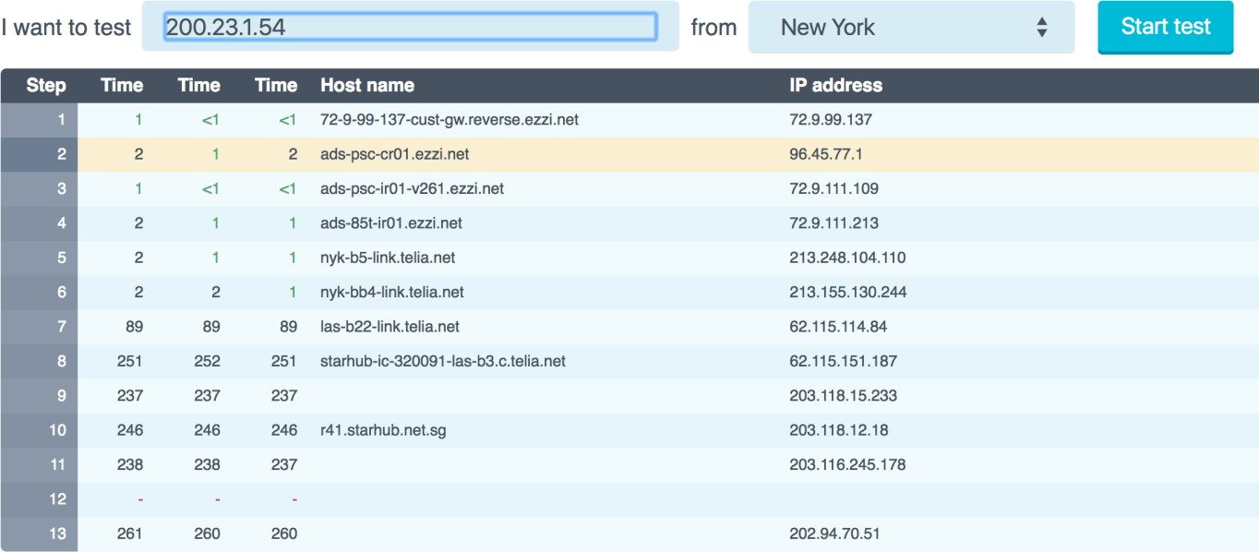

**Step 4:** On your computer, run traceroute using the IP address recorded in the previous step as the remote destination.

$ traceroute *<ip address from step 3>*

**Question 6 (10pt):** Record the output of traceroute when run in both directions above.

**New York**

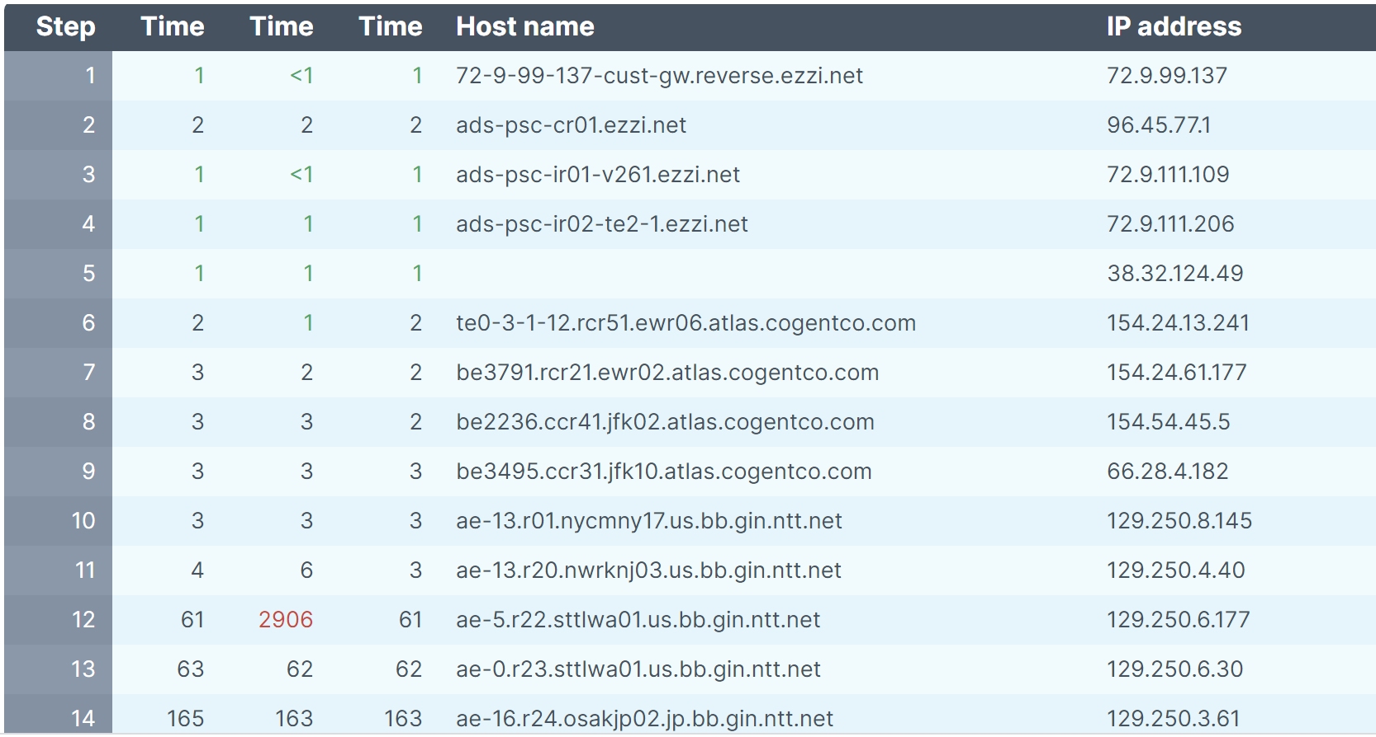

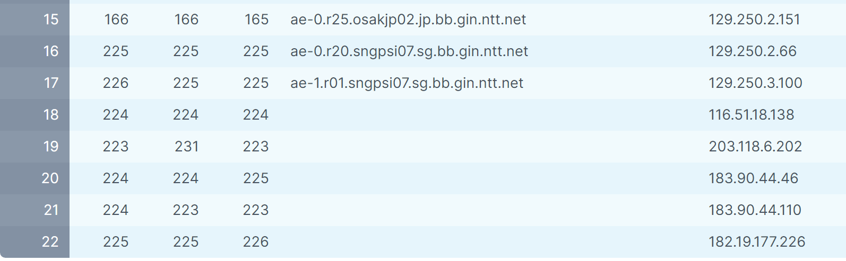

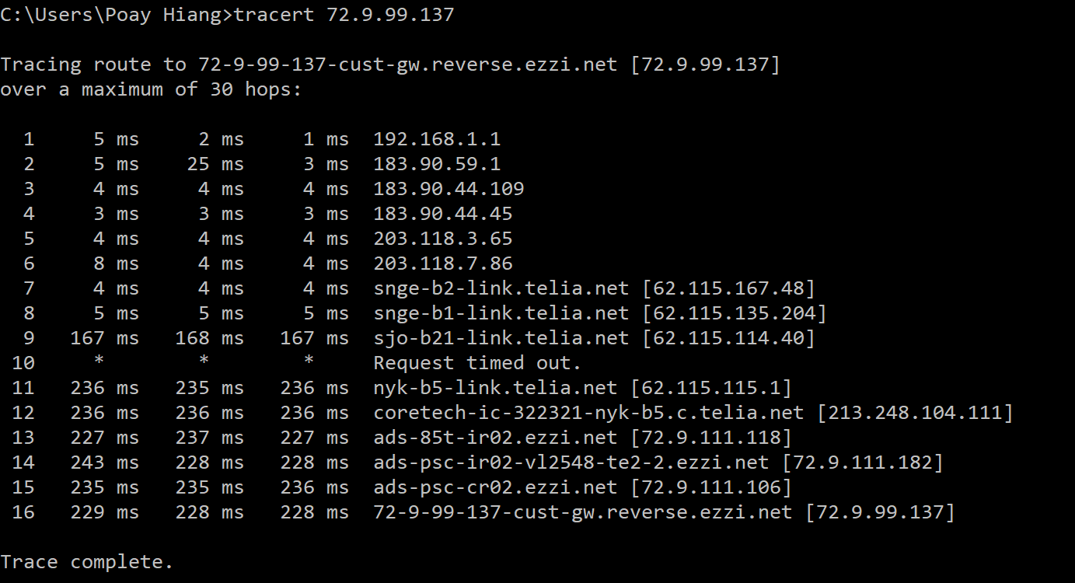

**Amsterdam**

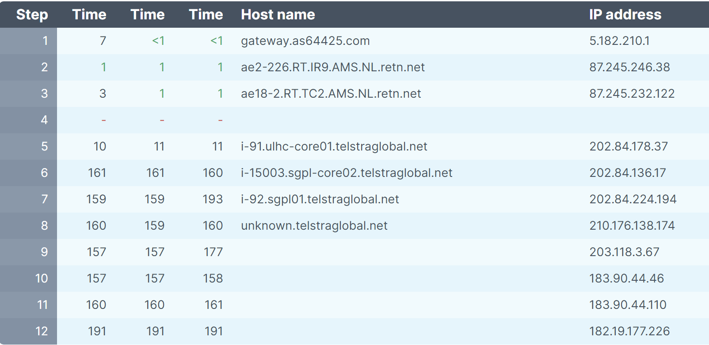

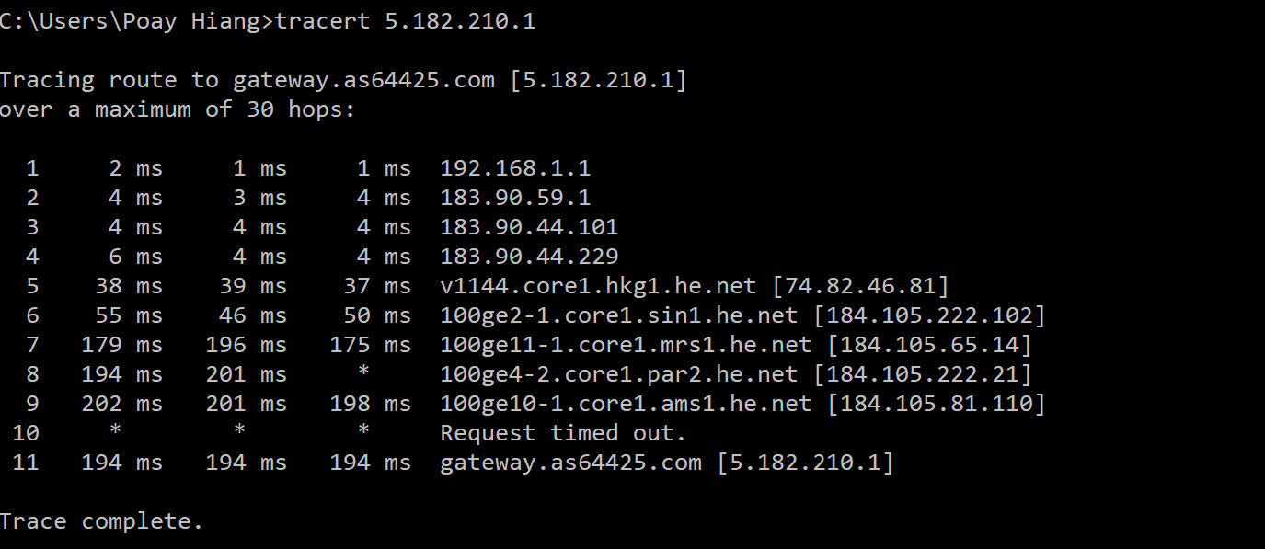

**Tokyo**

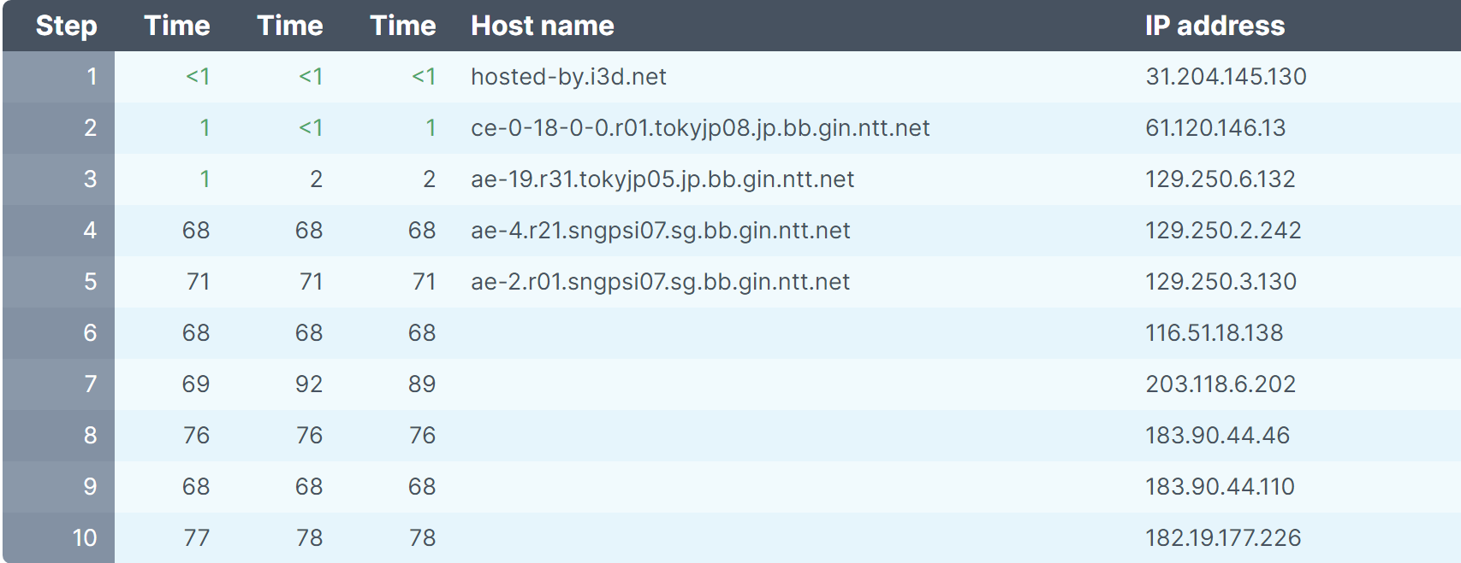

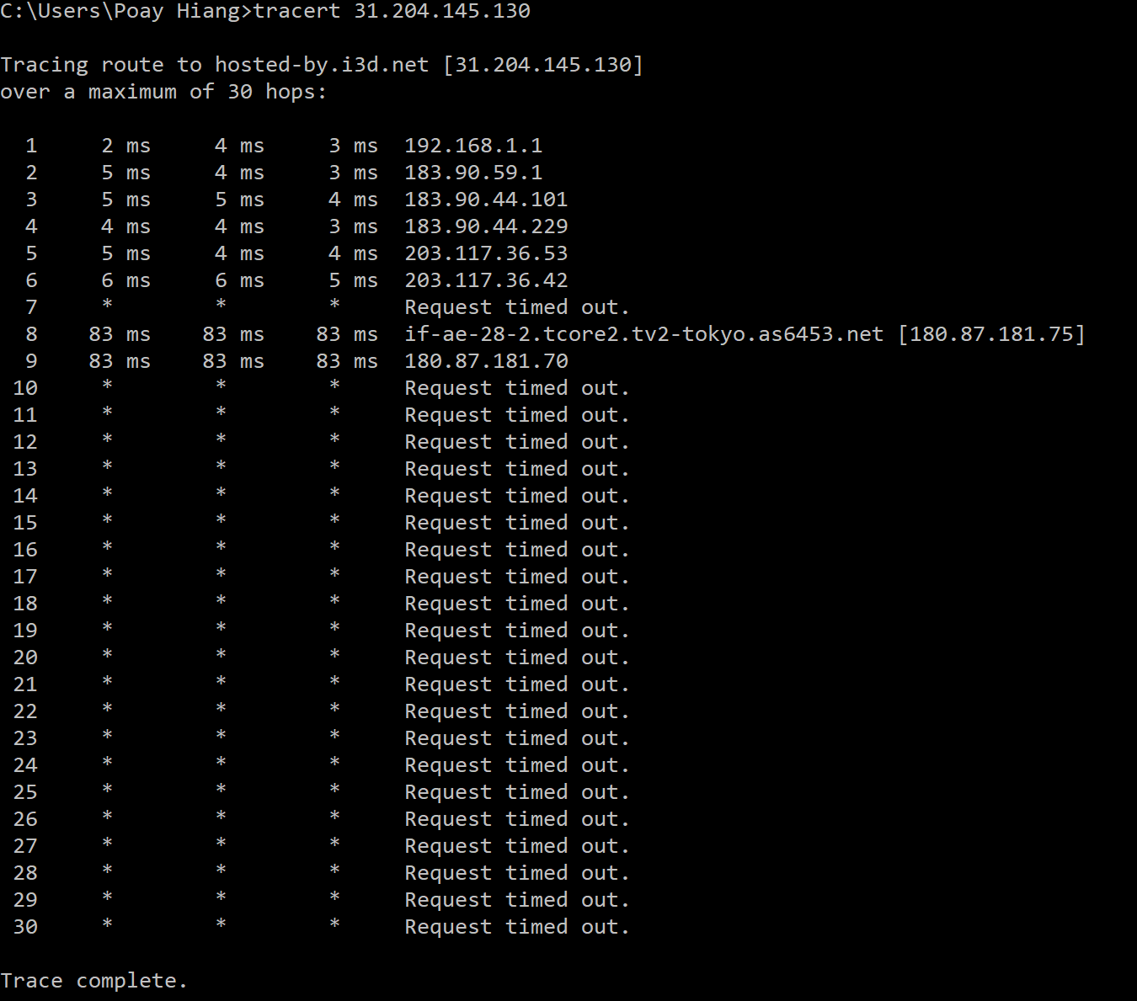

**Question 7 (10pt):** Describe anything unusual you might observe about the output. Are the same routers traversed in both directions? If no, why might this be the case?

The unusual thing about the observations is that when tracing from my IP address to Tokyo, the request timed-out. This may be because its IP address (31.204.145.130) blocks incoming ICMP packets.

Different routers are travelled in each direction. This is because from the source, the most suitable routers are picked for the subsequent hop. However, since the source is different for both directions and the router is chosen from the pool of i number of hops from the source, the resulting sequence of routers traversed will be different.